***THE NEWSLETTER OF***

Over The Rainbow

***RAINBOW: The OOSHC Services.***

***Term 2 & July Vacation Care 2025***

***Welcome back to all existing families and all our new families***

**What’s been happening at Central Ballina OOSHC**

**Term 2:** Our days have been filled with music and movement! Musical games have become a big hit, with children eagerly requesting their favourite songs to kick off both our mornings and afternoons. We’ve also had some wonderful conversations about NAIDOC Week. The children proudly shared stories of how they celebrated at school, and we’ve continued these important discussions and celebrations during our vacation care and after school program.

Afternoons on the oval have been filled with energy and teamwork. Group games like soccer, bullrush, and Red Rover are always popular, encouraging active play and cooperation. At the same time, some children have found joy in quieter activities for example meditating under the trees or using natural materials to build imaginative stick houses.

**.**

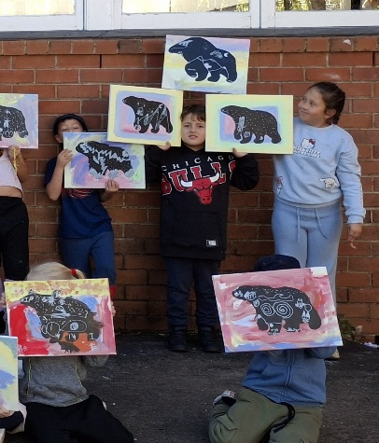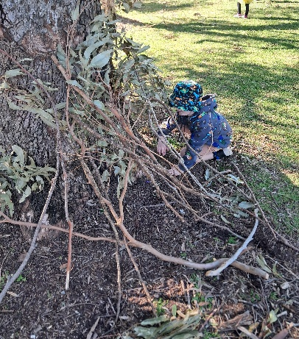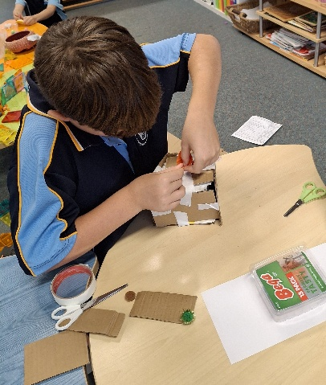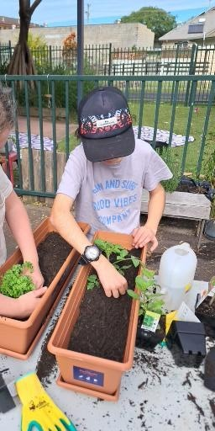

**Holiday Highlights:** One of the highlights was our sausage sizzle! The children had such a great time that all 40 sausages disappeared in no time!

We’ve also been getting our hands dirty (in the best way!) during our gardening experiences. The children have done an amazing job caring for our gardens by watering our herbs and flowers, keeping a close eye on our growing strawberries, and even adding their very own *grass heads* to the mix. It’s been a beautiful display of responsibility and teamwork.

Another exciting moment was Annie’s painting workshop. The children absolutely loved it, and the polar bear painting was a favourite!

Kind Regards Luke, Megan & Various Casuals

**What’s been happening at East Ballina OOSHC**

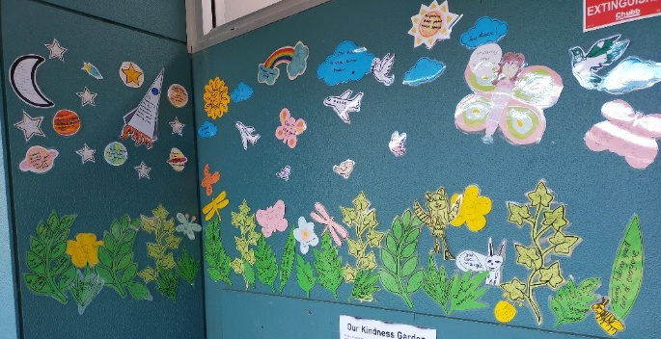

**Term 2**: This term we have been working on some wonderful collaborative projects involving children, families, and educators working together to bring our kindness garden and connect to country wall come to life. The children have played an active role in designing various elements for the two wall displays. A big thank you to all the families and children who contributed their time, ideas, we also want to thank everyone who added their voices and ideas to our connect to country wall. It's now a beautiful and meaningful reflection of the many ways we connect to the land around us, through nature, stories and culture.

Children have also really enjoyed engaging in physical activities at the playground and oval and various art experiences. The children have been inspired to create art after we read ‘The Spotty Dotty Lady’ by Josie Boyle.

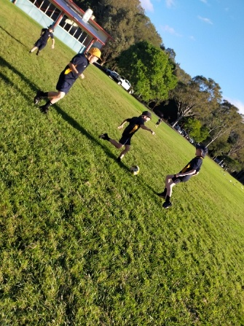

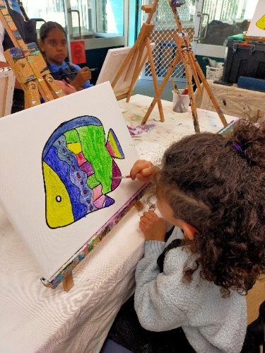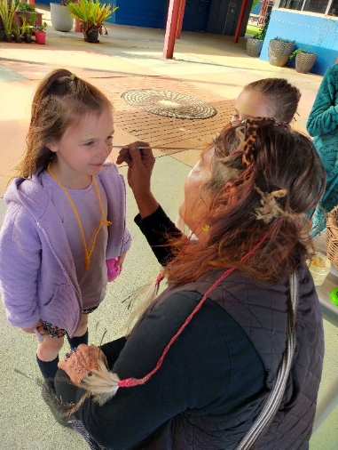

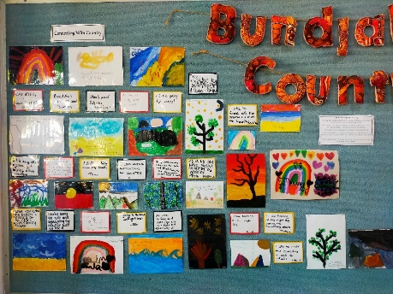

**Holiday Highlights:** This month, we celebrated NAIDOC week with an amazing variety of activities. Children engaged in Aboriginal inspired art, weaving, Indigenous board and card games, cooking Damper, exploring felt resources and creating with salt dough.

Connections to the community during these holidays were so engaging! We welcomed Aunty Lois, who shared Dreamtime stories, introduced children to ochre painting, created yarn headbands, and taught traditional cultural dances. This experience fostered respect and appreciation for Aboriginal and Torres Strait Islander cultures. We also had Annie from Good Evans Art Studio lead an engaging art class, Indi from Wild Rangers share fascinating animal facts and introduced the children to a range of native animals, and Shorty the Clown entertained everyone with giant bubbles and energetic, sporty games.

Kind Regards April, Kylie, Kristel, Kristin & Various Casuals

**What’s been happening at Lennox Head OOSHC**

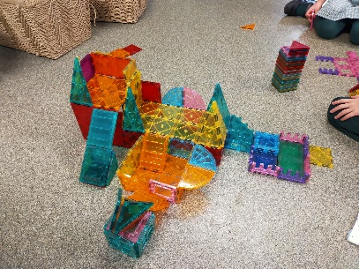

**Term 2:** We purchased some pickle ball sets for another outside physical activity; this activity has been great with children of all ages showing a lot of interest, educators have been joining in and teaming up with children as well. Children have also been requesting the climbing play equipment. They have been challenging each other to see how many times they can go across the monkey bars! Group construction play continues to be very popular, with the children often revisiting their creations they have saved on the shelf or creating new construction creations in different sessions.

Educators and children often have conversations about being kind to our friends. To extend this, we decided to start a kindness tree for the wall. We started by collecting natural bark to make the trunk. This now has started to become more of an ongoing project in the term with the children painting their patterns on the bark. Integrating natural elements into artistic projects for children can also foster a deeper connection and appreciation for nature.

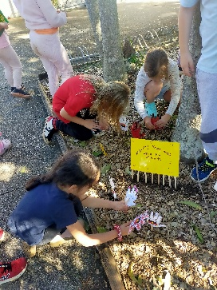

**Holiday Highlights:** We invited Aunty Lois from Aboriginal Cultural Concepts to visit the children in Vacation Care. Lois shared stories, languages and dances from our local Lennox Head area with the children. The children enjoyed listening and engaging with all the stories and dancing! Some of the other activities to celebrate NAIDOC week were students decorating their hands traced, then placing them in the garden for a show of hands.

Kind Regards Carol, Kim & various Casual

**What’s been happening at Teven Tintenbar OOSHC**

**Term 2:** We would like to thank Oscars Mum, Danielle that had donated a lot of Lycra material samples that have been the prefect size for the children to spark many lessons in basic hand sewing. The children focused this new skill to complete their own pillows to take home. We have also been creating some pipe cleaner spiders and snakes which a few children have enjoyed trying to scare people with. At both before and after school care, the children have been setting up schools and role-playing teachers, principals and different classes. This has been an all-ages experience lasting over weeks at a time.

In the morning, we have been utilising the court after 8:30 playing group games, even when introducing different games, they go back to the favourite ‘Bull Rush’

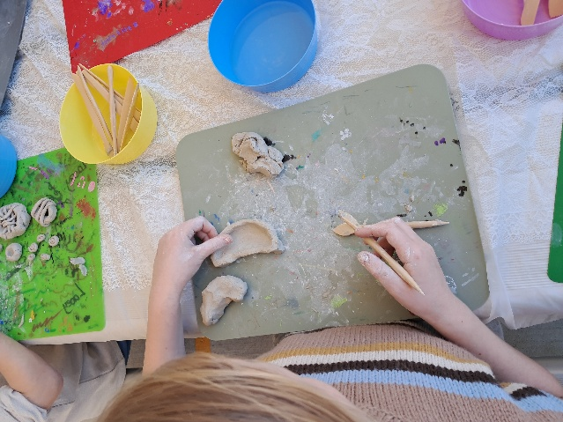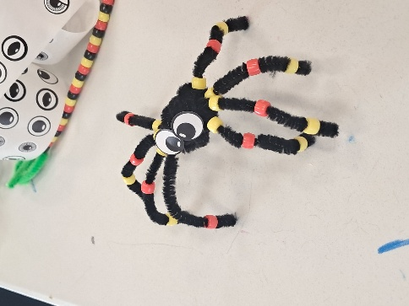

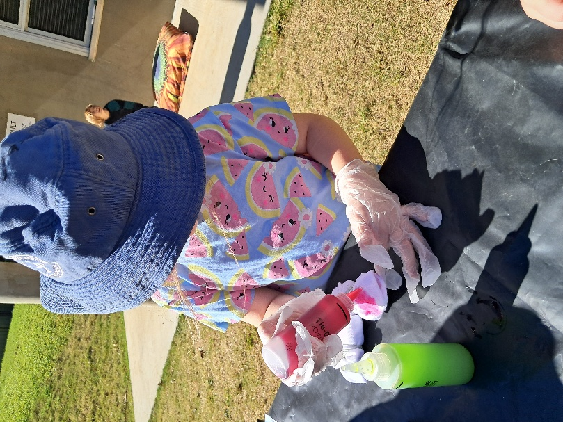

**Holiday Highlights:** The first day of Vacation care we got into the winter theme with a campfire on the oval and damper bread in the afternoon. This is always a fun experience with the children. We had lots of indoor and outdoor activities planned, some of the favourites was the pizza making day, toy swap, clay making, Just Dance challenge and of course Oobleck (goop). Our incursion that we had was an art class with Annie, Stories with Auntie Lois, a composting workshop and one of the stand outs was Cool Kids First Aid. This was so engaging and very informative, but child focused as well. As part of NAIDOC week we also celebrated the Torre Strait Islands with a Floral Friday.

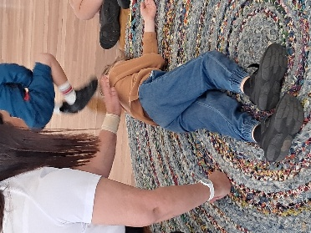

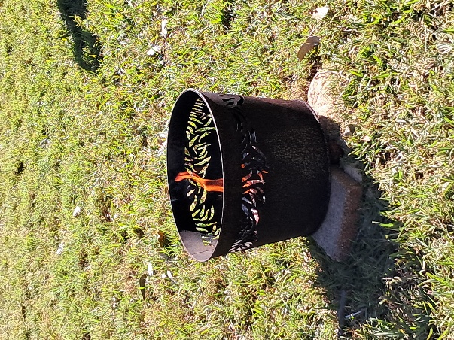

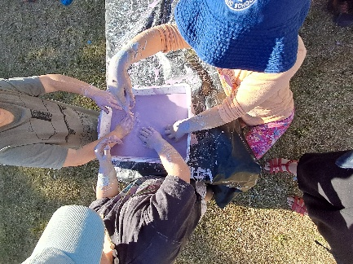

Kind Regards Steph, Eryn & Various Casuals

8 Ways Of Learning

At OOSHC, our team has recently been engaging in valuable professional development with Jessica Staines from Koori Curriculum. We've been learning about the **8 Ways of Learning**, an Aboriginal pedagogy that offers a meaningful and respectful approach to embedding Aboriginal perspectives into education.

The **8 Ways** framework helps us understand how many Aboriginal communities teach and learn through relationships, storytelling, visual learning, land-based experiences, hands-on activities, community links, non-verbal cues, and deep reflection. These ways include:

1. **Story Sharing** – Using personal and cultural stories to teach and connect.
2. **Learning Maps** – Visual tools that map out learning journeys.
3. **Non-verbal** – Learning through watching, doing, and non-verbal communication.
4. **Symbol, Image and Metaphor** – Using symbols and images to explain ideas.
5. **Land Links** – Connecting learning to the land and local environment.
6. **Non-linear** – Understanding that learning doesn't always follow a straight path.
7. **Deconstruct/Reconstruct** – Taking ideas apart and rebuilding them to understand deeply.
8. **Community Links** – Learning through connections with families, Elders, and community.

We are excited to be weaving these practices into our educational program. This approach not only supports all children’s learning styles but also fosters respect for Aboriginal culture and knowledge systems.

(image sourced via: <https://www.8ways.online/>).